SE2203 Lab 8 – UML State Diagram

Key Questions (Deliverable – out of 2 marks)

1. What three things must every UML State Machine model include?

***State*:** A situation of an object during which it satisfies some condition, performs some activity, or waits for some event

***Event:*** A specific occurrence (in time and space) of a stimulus that can trigger a state transition

***Transition:*** The movement from one state to another in response to an event

1. What is an internal transition?

An internal transition is shorthand for handling events without leaving a state and dispatching its exit or entry actions.

Activities (Deliverable – out of 4 marks) – Car Wash Control System (CWC)

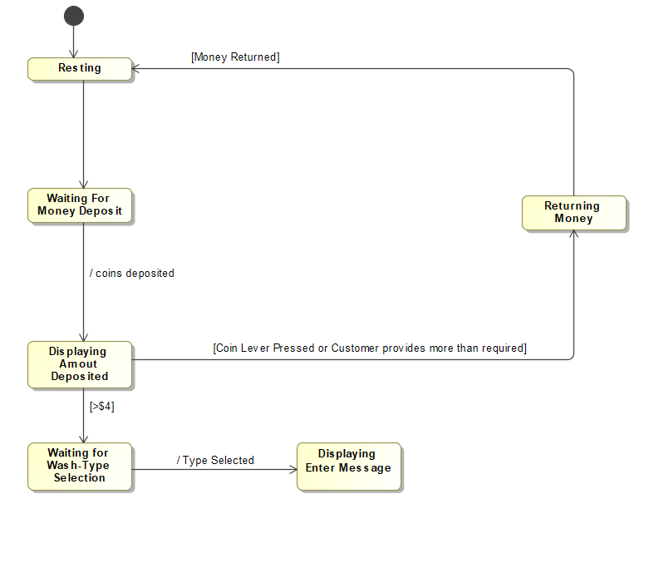

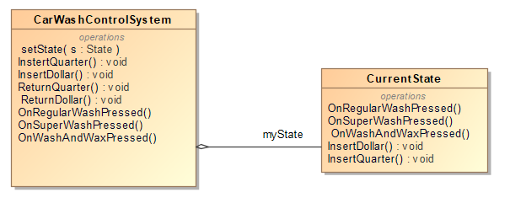

Problems (Deliverable – out of 4 marks)

1. Student enters the enrollment process system. The students have applied to programs and each program has a set of 3 rules that the students must have completed. The student is only eligible to accept the choice if they have passed all 3 rules.

For each student that is analyzed, they will first go through Rule1. If they passed that rule, then they will be checked for rule2. If they pass rule 2, they will be checked for rule3. If they pass rule 3, the student will be able to accept the program which they applied to or decline it. Whenever a student does not pass a rule at any point, the system will move on to their next choice and repeat the process of checking whether they have passed all the rules. Once the student has accepted a program or is completely out of choices. The system will move on to the next student if there are any. If there are not any more students, the system will stop.